Updates services
Installation and setup

© Copyright 2012

Table of Contents
Introduction 3
System Requirements 4
Needed information 5
Windows 5
Web 5
Database 5
Installing Updates service 6
Using the installation wizard 6
Uninstalling Updates service 11

Introduction
This document will describe how to install update notification services. These services allows CPR Broker to be notified if one or more person records have changed in a data provider database.
There are currently two services to be installed, DPR Updates and E&M Updates. The logic and installation procedures are almost the same for both. The screen shots in this document are based on DPR Updates Notification service. The instructions for E&M Updates Notification Service are identical.
Installation is one updates service per data provider database. It can only be attached to one instance of CPR Broker.
Before you begin, please make sure you have the requirement listed in the chapter System Requirements and also the information in chapter Needed information
Next, you can see the chapter Installing Updates servicefor details.

System Requirements
The service can be installed on almost all Microsoft operating systems.
For Windows 2008 you should also install the .NET 3.5.1 Feature via Server Manager.
SQL Server 2005 (or SQL Server 2008).
.NET Framework version 3.5 SP1.
.NET Framework version 4.0
Any computer capable of running the above software will also be capable of running an updates service.

Needed information
You will need to have some information before you install the updates service.

Windows
You will need a windows account that have administrative rights on the machine you are installing on.

Web
You need the URL of CPR Broker Part service. This should be something like
http://cprbroker/Services/Part.asmx

Database
You need to know the machine name and server instance of the SQL Server instance that holds the CPR data. You need to have access to instance. The account you use must be a member of the sysadmin role (used only during the installation to create the database).
You need to know the name of the database that has the CPR data. The suggestion is DPR (E_M). The installer will add a few triggers and tables to this database.
You should also determine the login information that you want the service to use in order to access the database. The installer can create it for you.

Installing Updates service
Copy the installer zip package to the computer. Unzip the package if needed.
You can install an Updates service using a wizard. Silent installations are not yet supported.

Using the installation wizard
Double-click the .msi file to launch and click Next.
Please note: On a computer with User Account Control (Vista/2008/ 7) please right click and select ‘Run As Administrator’

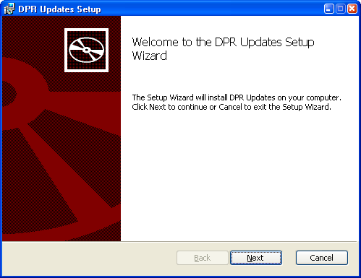
Click Next to continue.
The next screen will show the license terms. Accept and click Next.

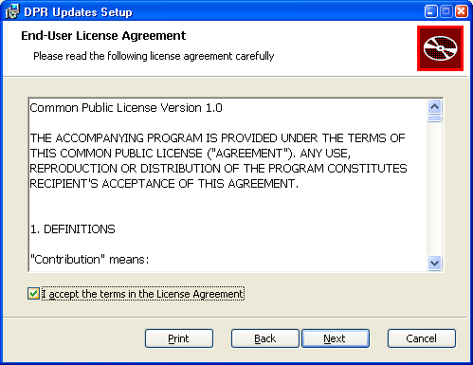
Now you will see this screen.
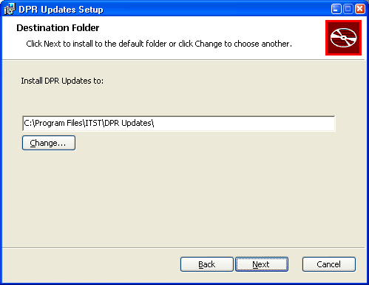
Choose where to install the files for Updates service. The default selection will most likely be a perfect fit. Click Next.

The installer now needs information about the database it will be associated with.

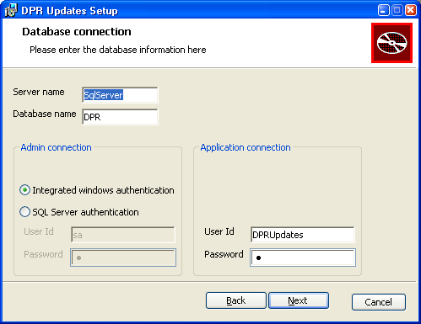
The Server name is the name or IP-address of the computer on which the SQL Server resides. It could be localhost if the SQL Server resides on the same computer as the web site. If the server has multiple instances, type [ServerName]\[InstanceName]. Example is localhost\SQLEXPRESS
Database name is the name of the database. It should be an existing database with CPR data of the data source you are linking with.
Admin login is used for logging into the SQL Server and creating the database with the necessary tables etc. Whether you should use Windows authentication or SQL Server authentication depends very much on your setup. If the SQL Server is on the same computer as the web site you should most likely use Windows authentication.
Application login is used by the service to connect with the database. The credentials needed for this purpose do not need to have as many privileges as the Admin login. Type the User Id and Password that you want the service to use. If the user exists as a login, the password has to be the correct user's password. If not, the installer will create a new SQL login for you. In all cases, the user will be given full privileges on the new created tables.
When you are satisfied with your settings, click Next. The installer will test the information you have provided. You will see an error message if the information is invalid. Please check the information and click Next again in this case.
The installer now needs information on where CPR Broker is installed.
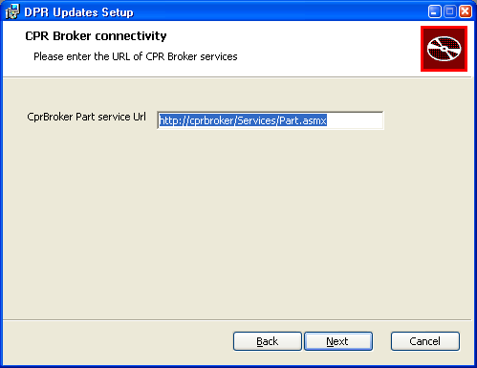
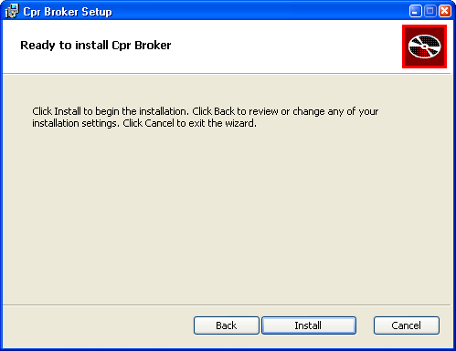
Enter the URL where Part.asmx service of CPR Broker is located, and click Next.
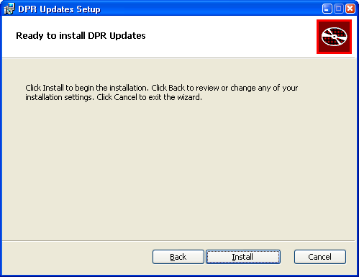
Now you are ready, click Install to start the installation process.
You will see the progress screen
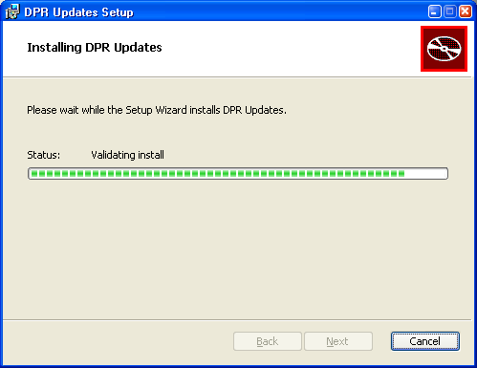
Wait until the process is finished. Then you will see this screen
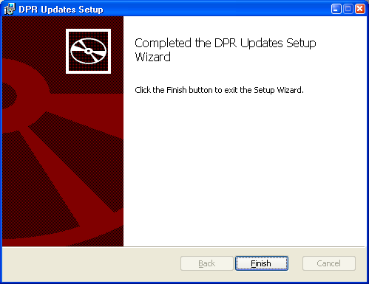
Now everything is OK. Click Finish to close the wizard.
Done!!

Uninstalling Updates service
To uninstall updates service, run this command as an administrator:
msiexec /x <.msi file> /lv* Uninstall.log
Alternatively, if you know the product code
msiexec /x {<product code>} /lv* Uninstall.log
You will be asked if you want to drop the database objects (triggers and tracking tables). The database itself won't be deleted.
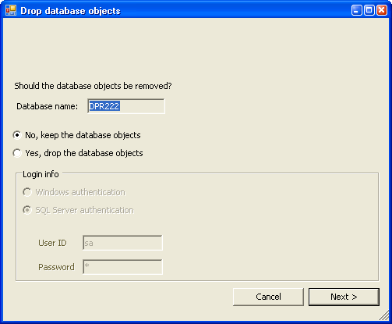
If you choose to drop the database(s), you may need to provide a user account that is a member of sysadmin role in order to delete the database(s).
Click Next.
Now wait for the wizard to finish, and then the updates service is removed from your system.

adresse
Studiestræde 14, 1.
1455 København K
email
info@magenta-aps.dk
telefon
(+45) 33 36 96 96

